**Project Report on**

BUS RESERVATION SYSTEM

**Submitted to**

**Jawaharlal Nehru Technological University, Hyderabad in partial fulfillment of requirements for the award**

**of the degree of**

**BACHELOR OF TECHNOLOGY**

**In**

**ELECTRONICS AND COMMUNICATION ENGINEERING**

**By**

**Jaddu Pavan 19BD1A0422**

**Ch Ramakrishna 19BD1A04A4**

**B Sai Sreyas 19BD1A0409**

**Bellary Ruchita 19BD1A0408**

**Under the esteemed guidance of**

**Mr.UMESH GOGTE Mr.SHANKAR M Mr.NARSIMHULU M**



**Department of Electronics and Communication Engineering KESHAV MEMORIAL INSTITUE OF TECHNOLOGY**

**Approved by AICTE, Affiliated to**

**JNTUH 3-5-1206, Narayanaguda,**

**Hyderabad - 500029**

**2021 – 2022**

**KESHAV MEMORIAL INSTITUTE OF TECHNOLOGY**

Approved by AICTE, Affiliated to JNTU, Hyderabad 3-5-1206, Narayanaguda,

Hyderabad - 500029.



**CERTIFICATE**

This is to certify that the project entitled **“BUS RESERVATION SYSTEM”**

being submitted by Mr. Jaddu Pavan (19BD1A0422), Mr. Ch Ramakrishna (19BD1A04A4) Mr. B Sai Sreyas (19BD1A0409), Mrs. B Ruchita (19BD1A0408) students of Keshav Memorial Institute of Technology, JNTUH in partial fulfillment of the requirements of the award of the

Degree of Bachelor of Technology in Electronic and Communication Engineering as a specialization

is a record of bonafide work carried out by them under my guidance and supervision in the academic year 2021 – 2022.

**GUIDE HEAD OF THE DEPARTMENT UMESH GOGTE**

**SHANKAR M**

**NARSIMHULU M**

**Submitted for the Project Viva Voce examination held on ................**

**EXTERNAL EXAMINER**

# DECLARATION

We hereby declare that the project report entitled "BUS RESERVATION SYSTEM"

is done in the partial fulfillment for the award of the Degree of Bachelor of Technology in Electronics and Communication Engineering affiliated to Jawaharlal Nehru Technological University, Hyderabad. This project has not been submitted anywhere else.

**Jaddu Pavan 19BD1A0422**

**Ch Ramakrishna 19BD1A04A4**

**B Sai Sreyas 19BD1A0409**

**Bellary Ruchita 19BD1A0408**

# ACKNOWLEDGEMENT

We take this opportunity to thank all the people who have rendered their full support to our project work. We render our thanks to Dr. Maheshwar Dutta, B.E., M Tech., Ph.D., Principal who encouraged us to do the Project. We are grateful to Mr. Neil Gogte, Director for facilitating all the amenities required for carrying out this project..We are also thankful to our guide Mr. Shanker Mr.Umesh Gogte, Mr.Narsimhulu for their valuable guidance and encouragement given to us

throughout the project work. We would like to thank the entire CSE Department faculty, who helped

us directly and indirectly in the completion of the project. We sincerely thank our friends and family for their constant motivation during the project work.

**Jaddu Pavan 19BD1A0422**

**Ch Ramakrishna 19BD1A04A4**

**B Sai Sreyas 19BD1A0409**

**Bellary Ruchita 19BD1A0408**

**ABSTRACT**

Problem Statement

Bus reservation system is a very simple project showing the implementation of class along with the object of C language. This project will help you learn how to create structures and Linked List based project. Here, the user can perform tasks like Store bus information, reserve bus seat, show reservation information and show information regarding the buses available.

Developed as a console application without GUI, this bus reservation in c uses file handling to store the bus information.

Project Abstract

Travel industry is evolving day to day. As the industry evolves the need to digitalize all the transactions becomes need of the hour. This project which is implemented on C platform helps to manage bus bookings. This Bus Booking System is a easily deployable, integrated end-to-end system starting from booking the bus for desired from and to locations.

Existing System

The existing Bus Booking System is not completely computerized. The customer has to visit any booking branch if he wants to book a ticket. Bus scheduling, ticket booking, bill generation and many other operations are done manually. This may lead to incorrect entries and there is a lot of room for errors as the data is not completely synced. The availability of seats is not centrally maintained and the travel operator is not fully aware of the availability and occupancy of the seats in his buses. This is the major bottle neck.

## **Proposed System**

## Simple Bus Reservation System based on the concept of reserving bus seats for the passengers. This software is user friendly , where the user can freely use its feature. This project contains limited features, but the essential one.

Here, the user can perform tasks like Store bus information, reserve bus seat, show reservation details and information regarding the buses available. This project is implemented by using Data Structures.

The application is reduced as much as possible to avoid errors while entering the data. It also provides error message while entering invalid data. No formal knowledge is needed for the user to use this system.

**INTRODUCTION OF THE PROJECT**

The "Bus Reservation System" has been developed to override the problems prevailing in the practicing manual system. This software is supported to eliminate and in some cases reduce the hardships faced by this existing system. Moreover this system is designed for the particular need of the company to carry out operations in a smooth and effective manner.

Data Structures used in the project is as follows:

* Array
* Linked List
* Queue
* Binary Search Tree
* Hashing
* User Defined Header Files
* Text Files
* Structures

Every organization has challenges to overcome and managing the information of Ticket, Bus, Passenger , Employee. Every Bus Ticket Booking System has different Bus needs, therefore we design exclusive management systems that are adapted to your managerial requirements. This is designed. assist in strategic planning, and will help you ensure that your organization is equipped with the right level of information and details for your future goals.

**Feasibility Study:**

After doing the project Bus Reservation System, study and analyzing all the existing or required functionalities of the system, the next task is to do the feasibility study for the project. All projects are feasible given unlimited resources and infinite time.

Feasibility study includes consideration of all the possible ways to provide a solution to the given problem. The proposed solution should satisfy all the user requirements and should be flexible enough so that future changes can be easily done based on the future upcoming requirements.

A. Economical Feasibility

This is a very important aspect to be considered while developing a project. We decided the technology based on minimum possible cost factor.

* All hardware and software cost has to be borne by the organization.
* Overall ,we have estimated that the benefits the organization is going to receive from the proposed system will surely overcome the initial costs and the later on running cost for system.

B. Technical Feasibility

This included the study of function, performance and constraints that may affect the ability to achieve an acceptable system. For this feasibility study, we studied complete functionality to be provided in the system, as described in the System Requirement Specification (SRS).

C. Operational Feasibility

The proposed system is not GUI and specifically a C based that is very user friendly and all inputs to be taken all self-explanatory even to a layman. Besides, a proper explanation is given to let know the essence of the system to the users so that they feel, comfortable with new system. As far our study is concerned the clients are comfortable and happy as the system has cut down their loads and doing.

**Project Requirements Specifications:**

1. System Requirement

The requirement description concerned with the study of the existing system with the aim of defining and put together the requirement of the proposed system. It is accomplished with the aid of user requirements. The analysis stage was in details carried out in focus of the functionality top level diagram at National Transportation Commission (NTC) transport division.

1. Requirement Specification

Requirement Specification a whole explanation of the activities of a system to be developed and may include a set of top level diagram that describe connections the users will have with the software. In addition it also comprises non-functional requirements.

**SYSTEM IMPLEMENTATION:**

Bus Booking System Modules

This application is divided into 2 main modules

* Users Module

This module provides the user to use the functionalities such as Services available for places, Reservation in which the user has options as seat selection, ticket confirmation and cancellation of the ticket along with total price of the no of seats booked.

* Management Modules

This module provides overview of the available bus details, employee details, passenger list , the revenue generated . One can get the access of the management by entering with the login credentials.

**User Module:**

This module describes about the following functionalities:

1.**Services available for places:**

All the available places get displayed for which the required bus services are provided. The user gets to select from given places the respective source and destination he/she wants to travel.

2. **Reservation:**

* The user must enter the from and to ,from the given places and date , the bus travelling to particular location details get displayed where details such as bus type , bus number, bus id ,driver and conductor name gets displayed
* If the user want to continue with reservation he should enter the bus number of the respective location he/she wants to travel.
* Now options such as Seat selection , ticket information , cancellation get displayed , from which user has to select one.

**a. Seat Selection** : The seats available in the respective bus gets displayed, the user should first enter the number of seats he/she wants to book or reserve then the user has to enter the desired seat number along with the details (such as name l, age ,phone number ).After entering the details ticket confirmation gets displayed where a ticket id is assigned to the passenger and also the price for the no of tickets gets displayed.

**b. Ticket Information:** When the user wants to know the ticket information he needs to enter the bus number along with ticket id which is given to passenger at the time of ticket confirmation.

**c. Cancellation**: When the user wants to cancel the ticket he needs to enter the bus number and ticket id .

3. **Contact us (enquiry)** :

It provides details about the management such as the name of bus corporation , contact number and email id .

**Management Module:**

For the admin to enter into the management module login procedure is implemented.

**Sign up / Login:** For the admin to login he should have an existing account , if else an account is created using sign up where registration is necessary. After the registration an account is created for the admin , now he can login into management module using login credentials such as username and password.

**When the login is successful the below modules get displayed**

**1.Employee -** The admin has a provision to add an employee , display employee details and delete an employee (here employee is driver and conductor) When the admin wants to add an employee he should also enter several details to adding employee along with the id of employee , where for employee details display is done using the employee id.

**2.Bus -**The admin has a provision to add the bus , delete the bus and display bus details . Here bus is added for every bus entry admin should confirm whether he wants to continue the entry of adding buses , the bus are added into the queue and when the queue is full the details gets copied into file.

**3.Passenger-** For the admin to view the passenger list of passengers travelling along a particular source and destination , he should enter the respective bus number , where the passenger list gets displayed. The passenger list only available for the admin in the management module.

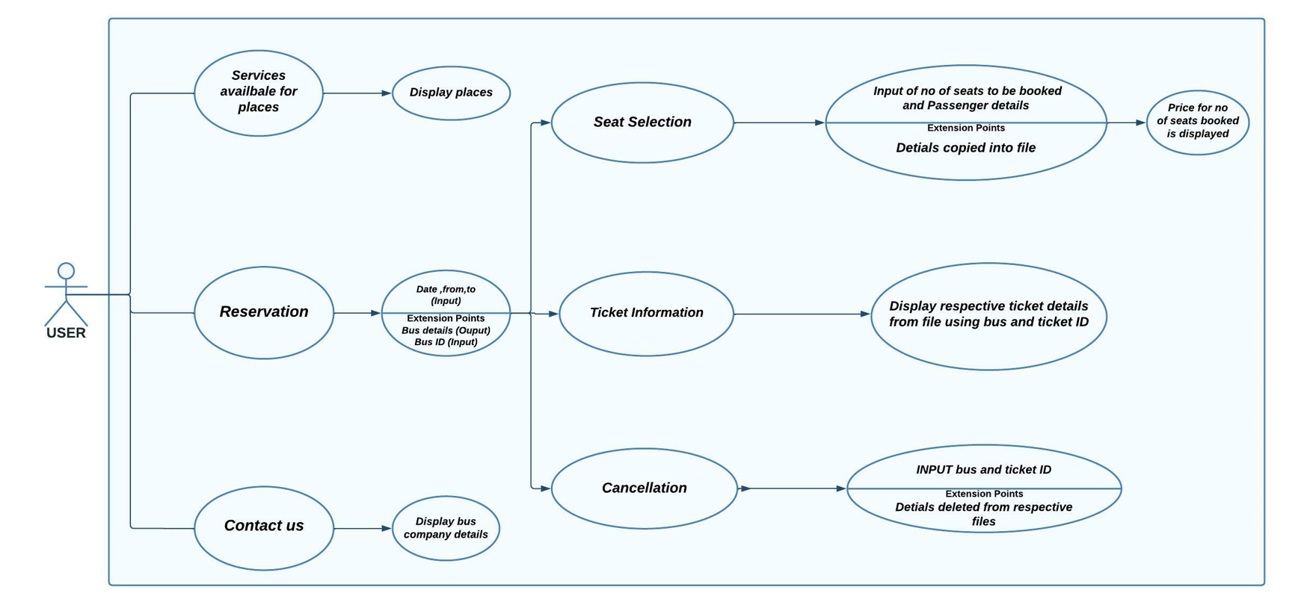 **USE CASE DIAGRAM**

Fig(a): User Module Use case diagram

The user module gets displayed before the user from which user can select his/her desired options where he can book seat in the bus and a confirmation ticket is displayed along with the passenger details.

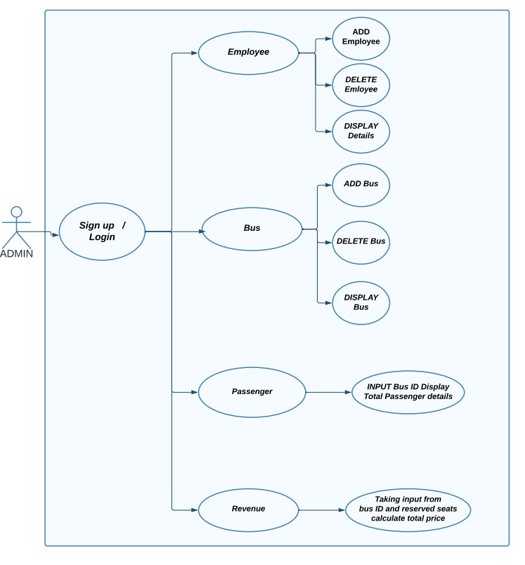 Fig(b): Management Module Use Case Diagram

The management module can be accessed only with the login credentials provided of which the admin should be aware of , if the admin is new he needs to sign-up. After the login is successful, the admin will be displayed with the employee , bus , passenger , revenue submodules through which he can handle the managerial requirements.

**Linked List**

A Linked List is a linear data structure. Every linked list has two parts, the data section and the address section that holds the address of the next element in the list, which is called a node.

* Why linked list ?

Linked List is used in the present Bus Reservation project in Reservation module . Here we are using linked list for creating nodes and appending the relavent passenger details into the node and as the passengers get added on, the nodes are linked in linear form so that when these get displayed every passenger is connected through the node link.

**Hashing**

Hashing is a technique or process of mapping keys, values into the hash table by using a hash function. It is done for faster access to elements. The efficiency of mapping depends on the efficiency of the hash function used.

* Why hashing?

Hashing is used in here where an array of bus numbers is created ,these bus numbers act as key. If the passenger wants to travel through the bus the passenger gets stored as value to the key , as many passengers travel through a single bus , these passengers are acting as values and linked to next through linked list to the key ,where key is the bus number.

**Binary Search Tree**

A binary search tree follows some order to arrange the elements. In a Binary search tree, the value of left node must be smaller than the parent node, and the value of right node must be greater than the parent node.

* Why BST?

Binary search tree is used in the Management module in the employee submodule. Here employee details are inserted into the left and right subtrees using a root node which created at the time of insertion of the first employee .The other employee details are entered into respective subtrees using the root node. Here for searching the employee and displaying his details BST is used where searching is done in inorder fashion.

**Queues**

A queue is a linear data structure to store and manipulate the data elements. It follows the order of First In First Out. In queues, the first element entered into the array is first element to be removed from array.

* Why Queues?

Queues is used in Management module in Bus submodule. Here Queue size is fixed and buses are inserted into the queue when entry is made where each time the admin is asked to empty the queue into the files , if yes then queue is made empty and if no the admin can continue entries.

**Code Snippets**

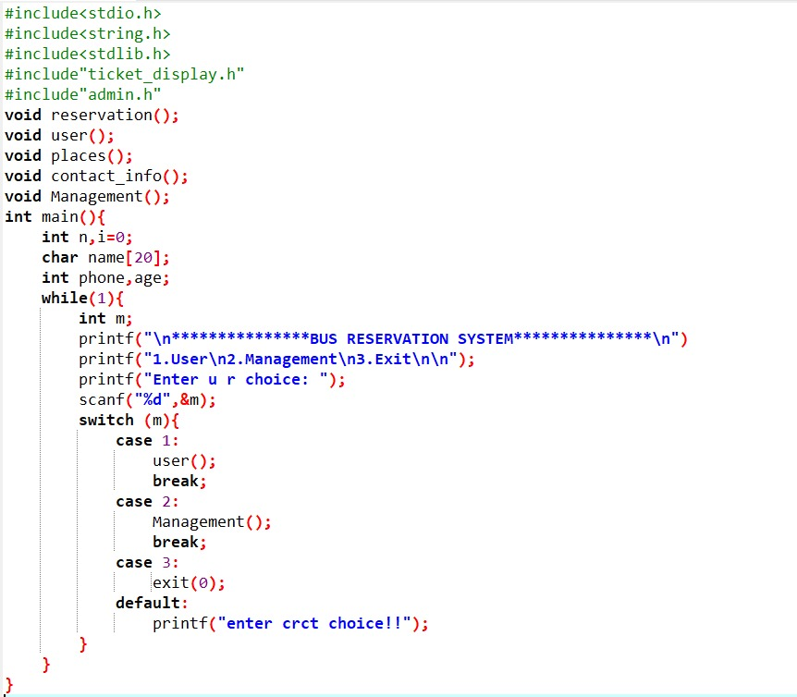Code snippet of main.c

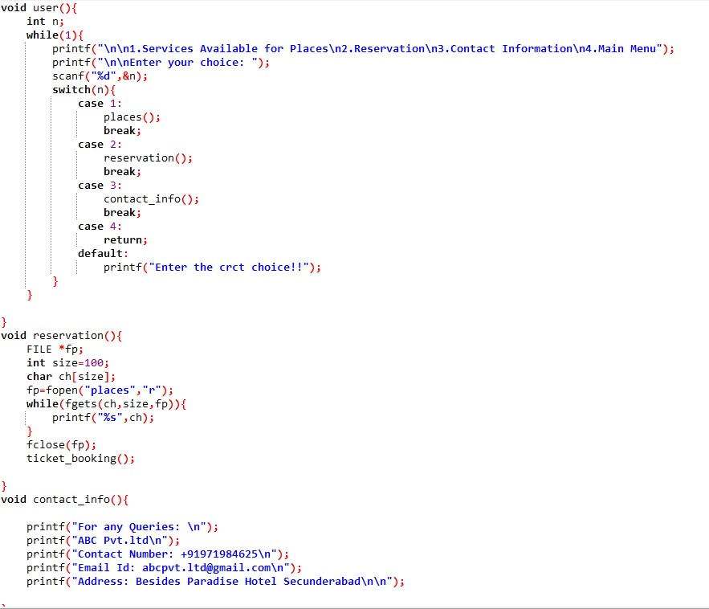

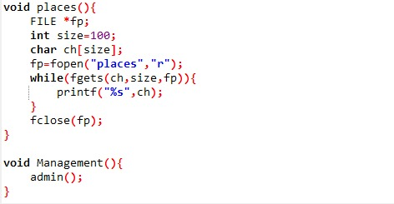

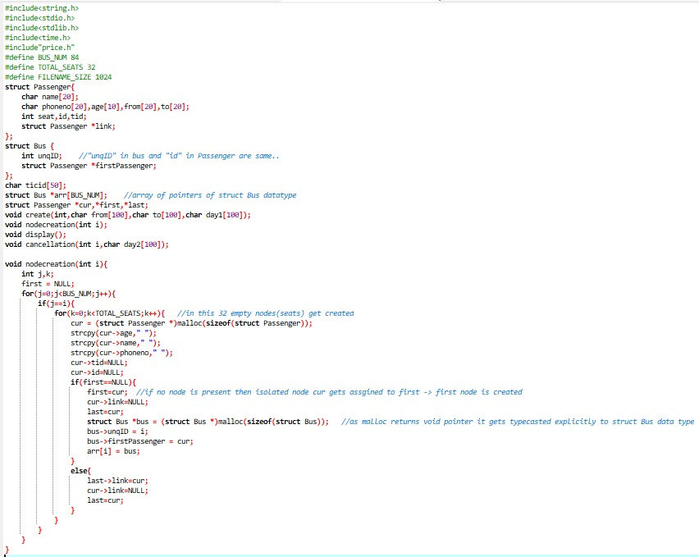Code snippet of seat.h

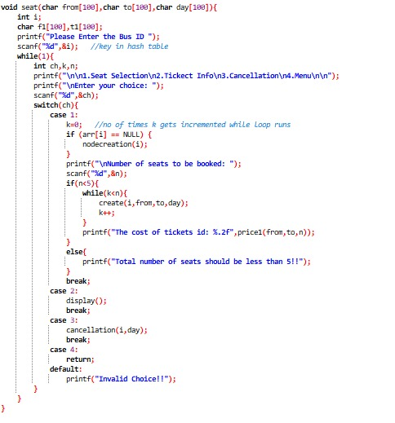

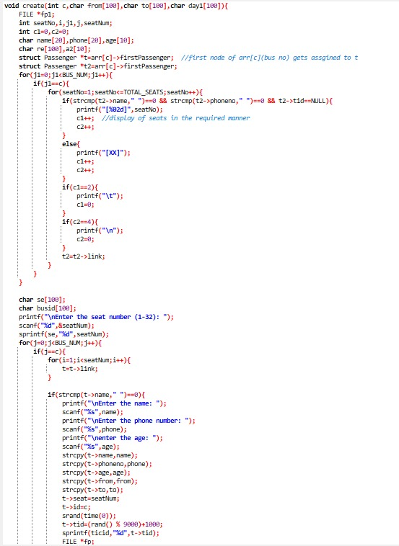

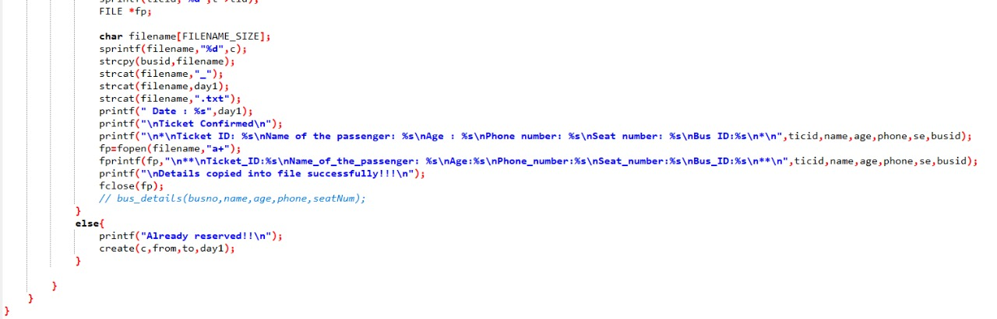

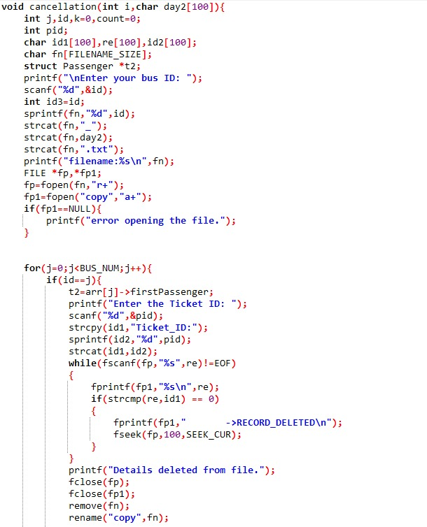

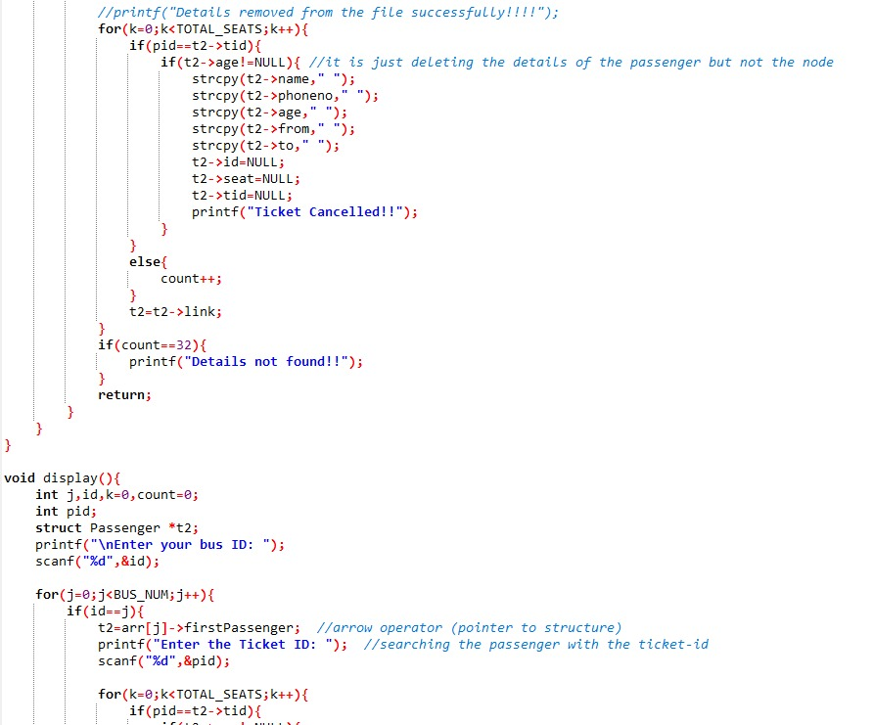

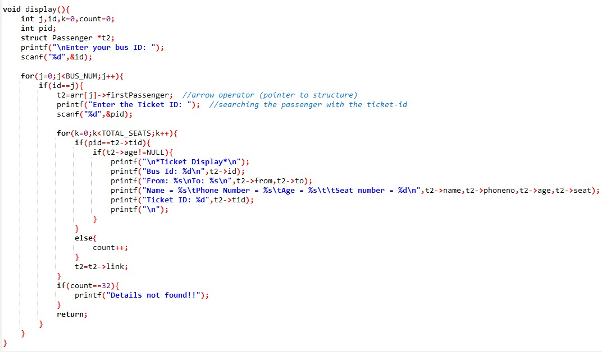

Code snippet of ticket_display.h

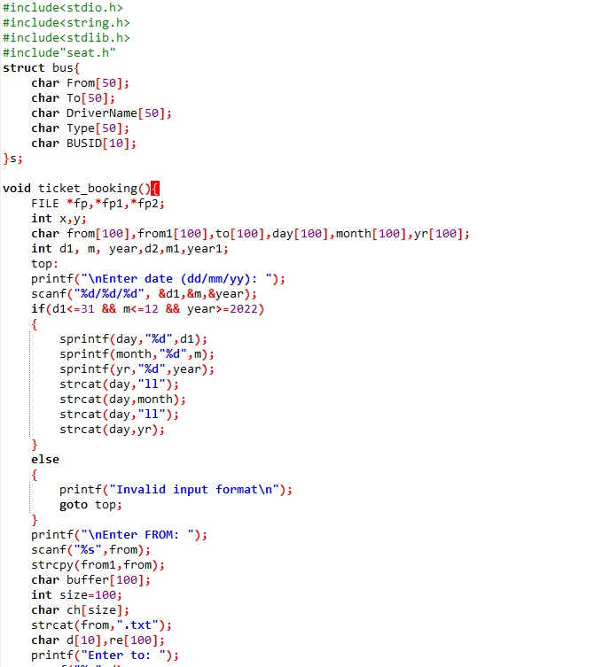

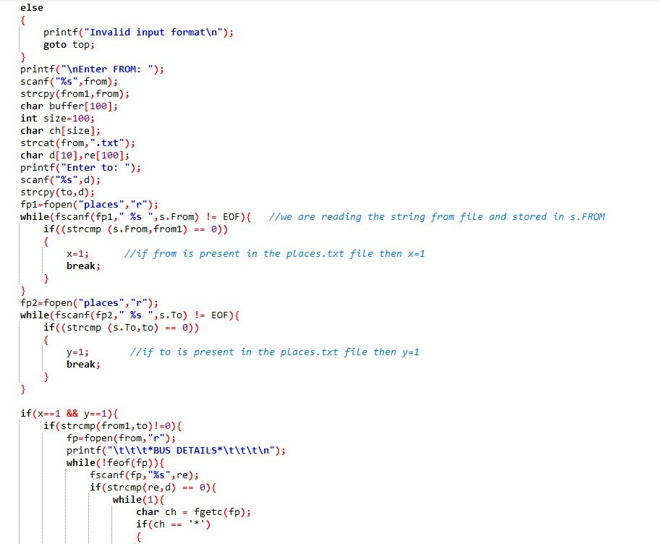

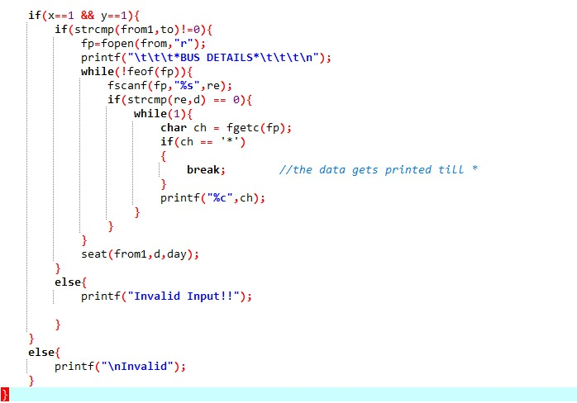

Code snippet of price.h

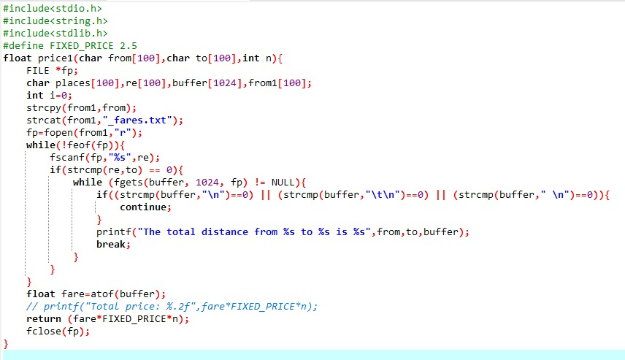

Code snippet of admin.h

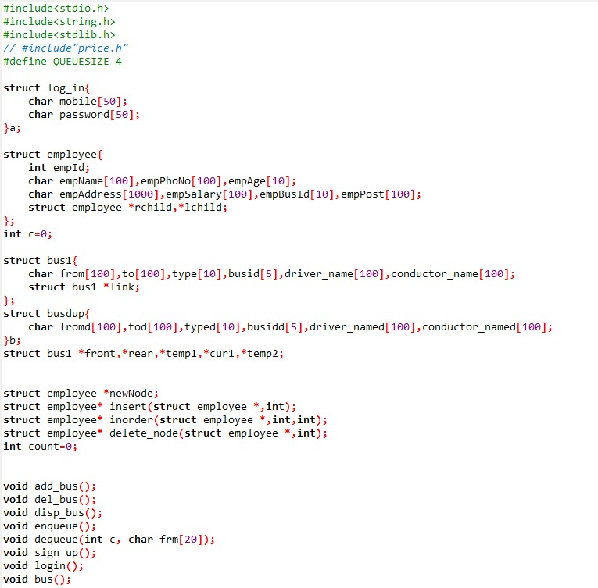

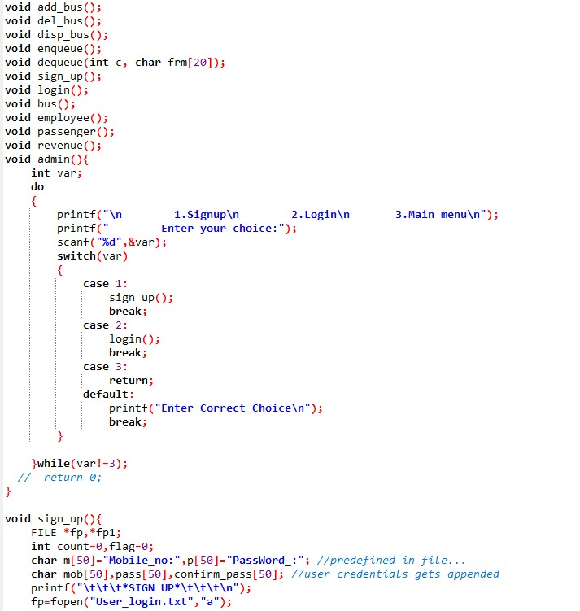

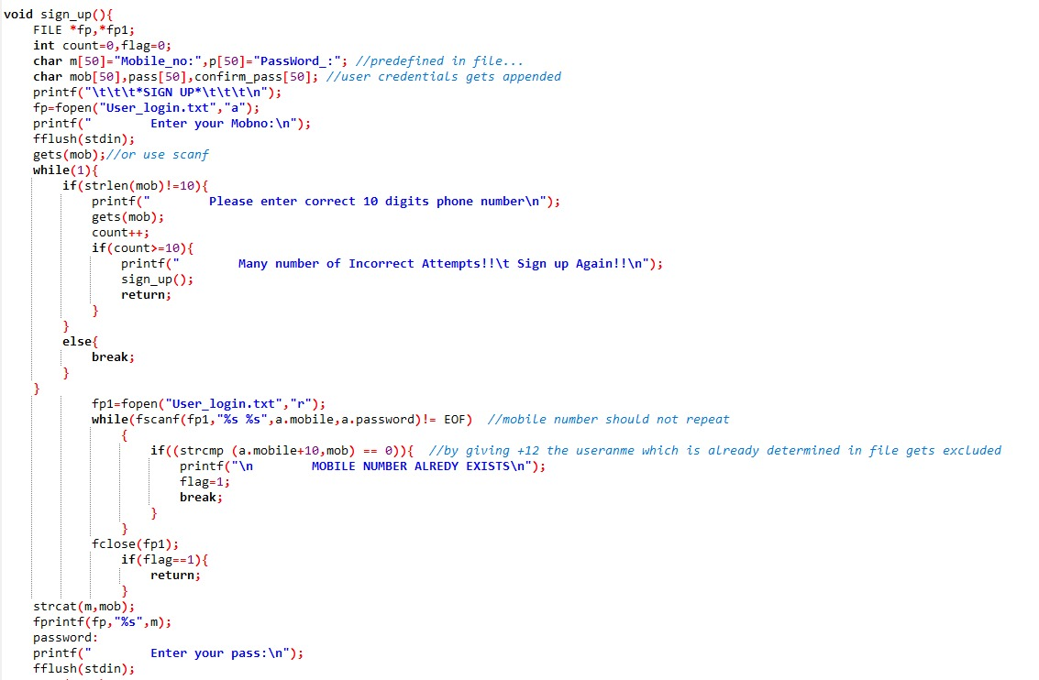

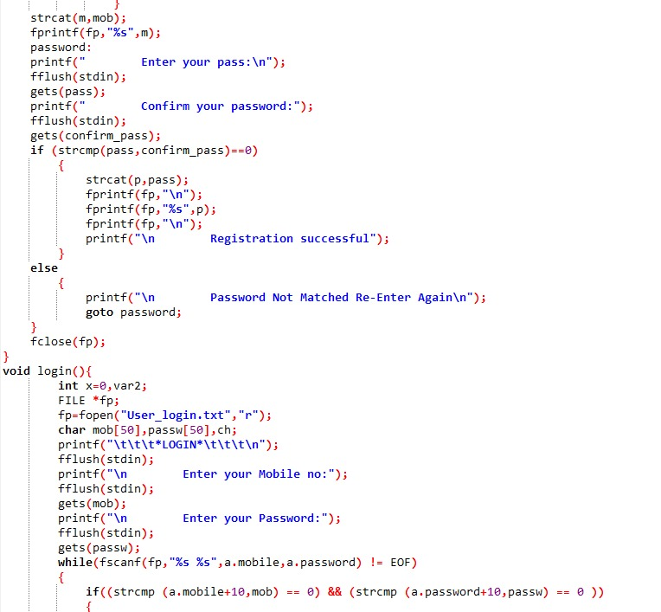

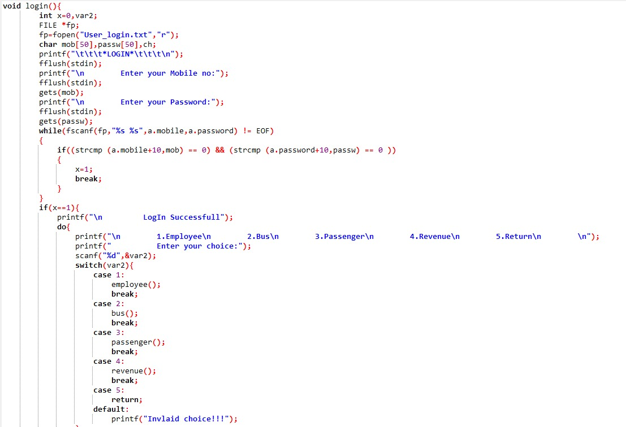

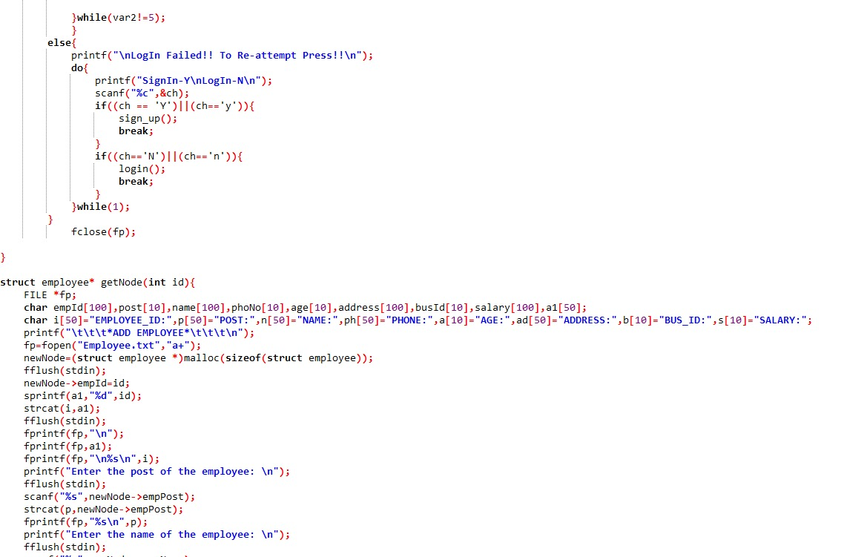

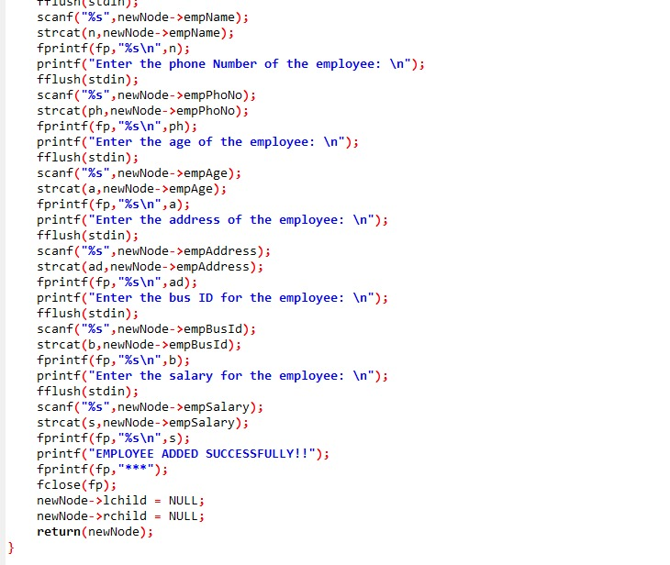

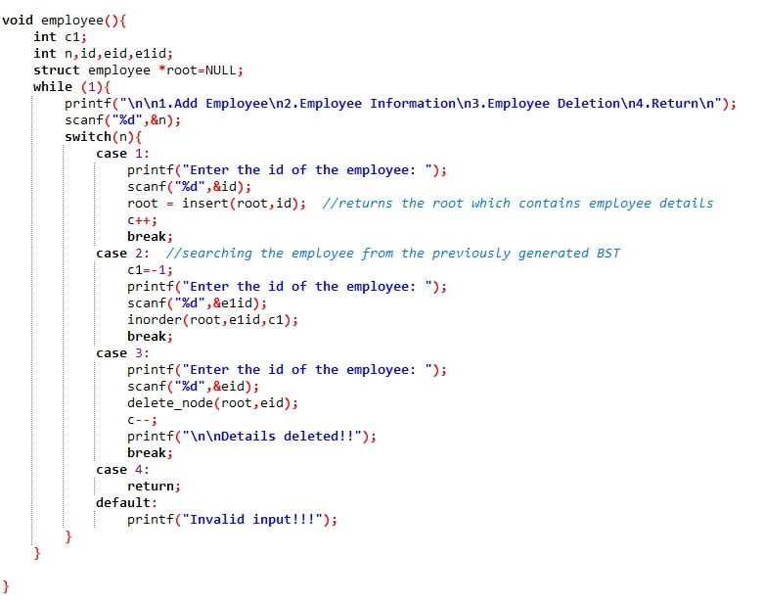

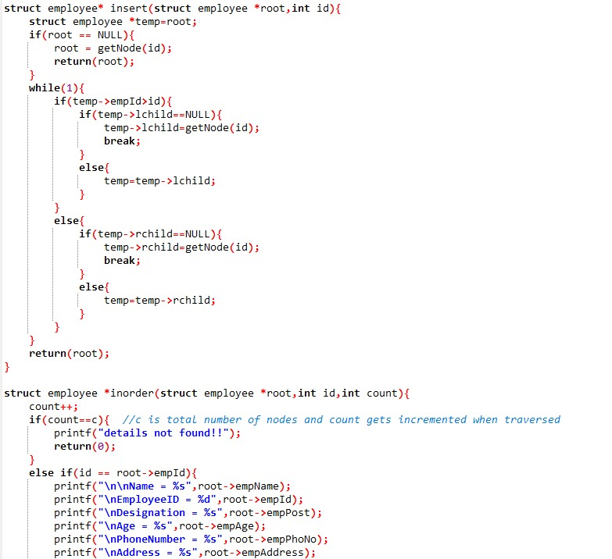

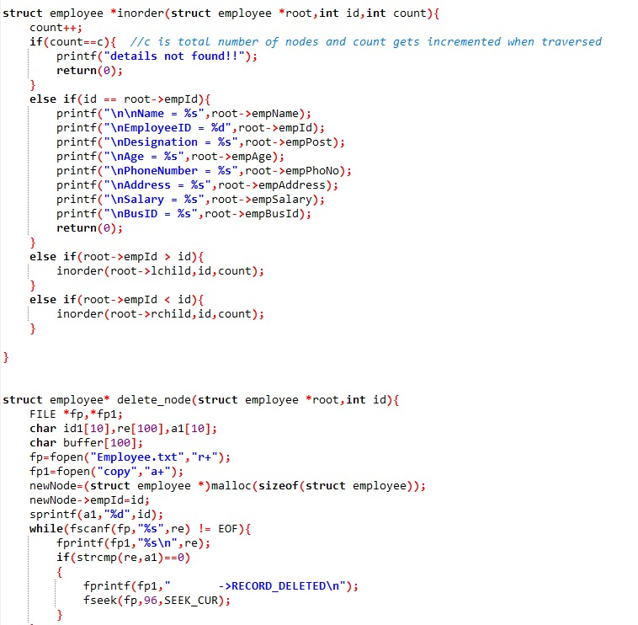

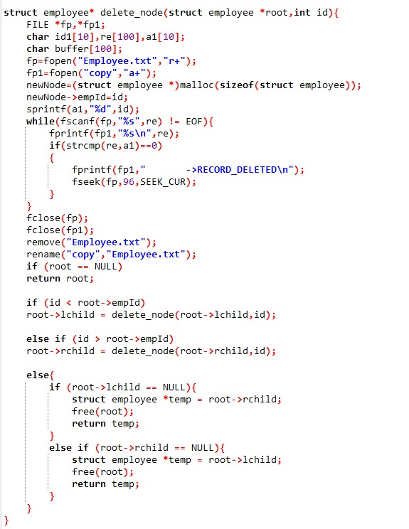

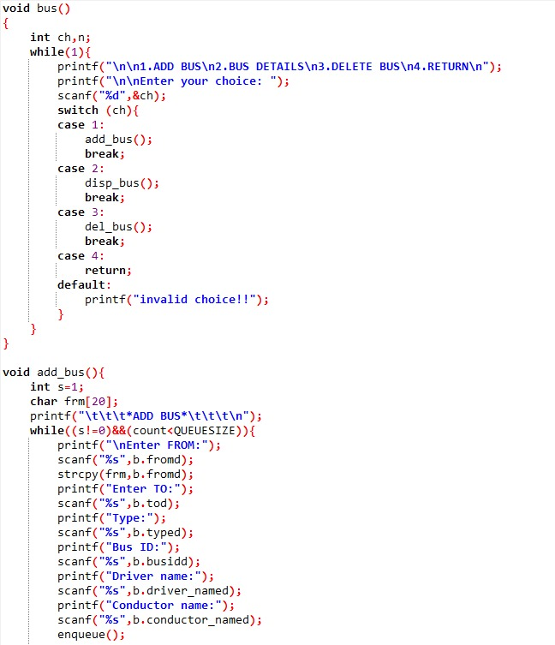

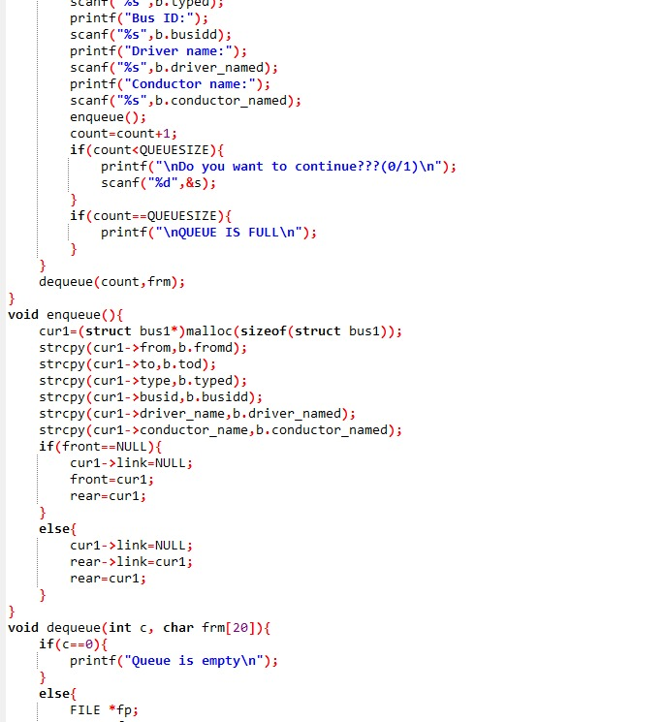

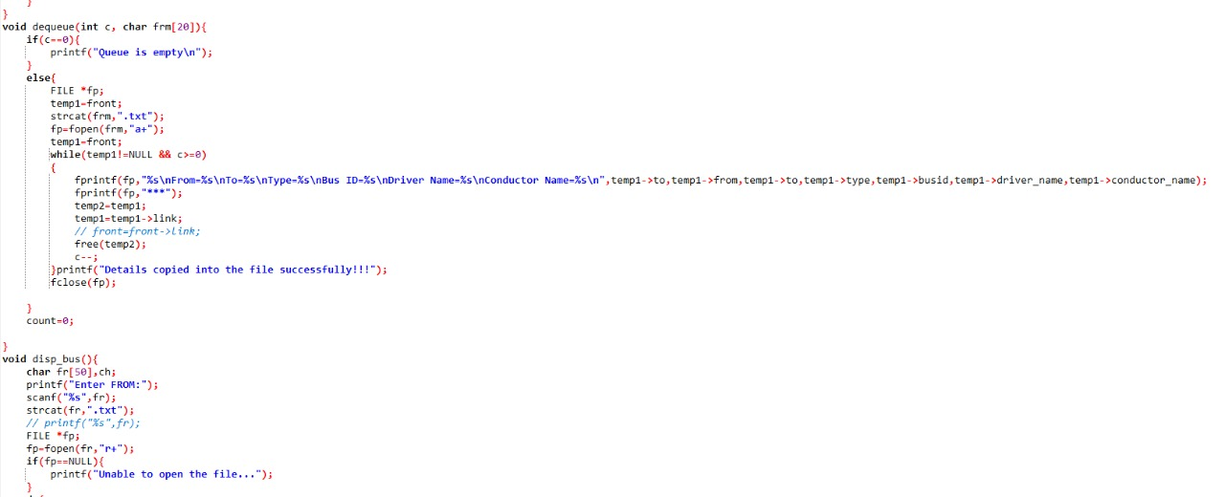

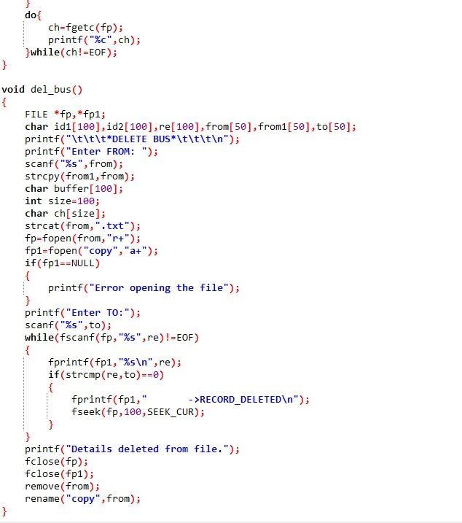

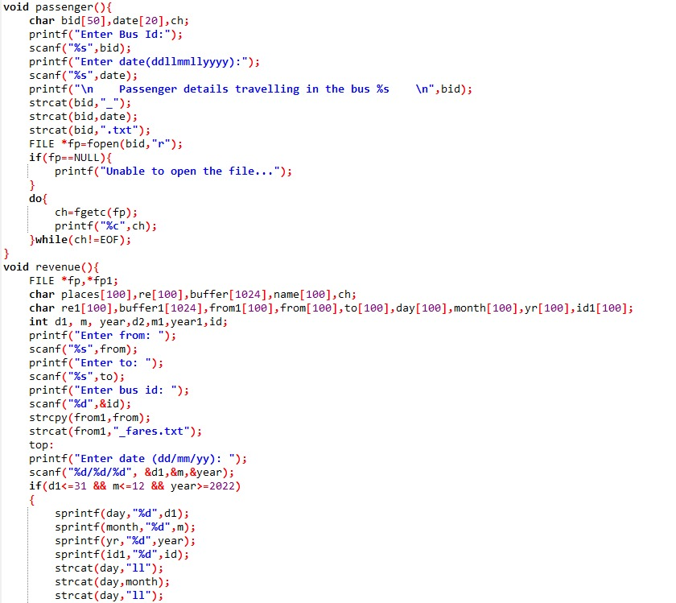

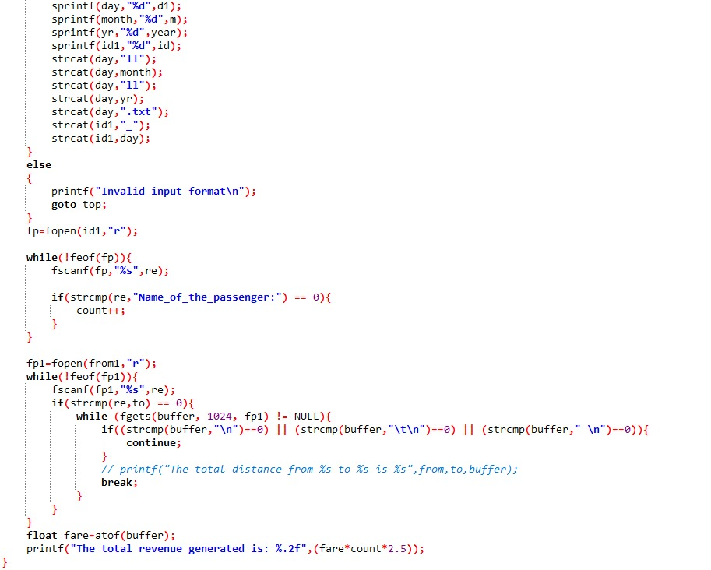

Future scope

As mentioned above this project contains limited features but essential ones .In our project , there is scope for further modifications that can be made in the management module , where data structures such as stacks can be implemented for deletion of bus where in when the bus is deleted it can be stored in stacks and and a special feature undo can be implemented where the last deleted is poped from the stack back to node.

**Conclusion**

Finally, in Bus Reservation System, we have developed a secure, user-friendly Bus Reservation System. This Project basically provides Bus information and regarding bus information.This is a databased system in which we store the information of the passenger,bus, employees and other relevant data using Files.

We observed the working of the Bus reservation system and after going through it, we get to know that there are many operations, which they have to do manually. It takes a lot of time and causing many errors while data entry. Due to this, sometimes a lot of problems occur and they were facing many disputes with customers.

To solve the above problem, and further maintaining records of passenger details, seat availability, price per seat, bill generation, and other things, we are developed a computerized reservation system. By using this software, we can reserve tickets. The customer can check the availability of buses and reserve selective seats.The project provides and reviews all sorts of constraints so that the user does give only user data and thus validation is done in an efficient manner.